## Issues and Changes made on Jboss 7.1.1 EAP for making the MDIAV running (Same issues encountered with Jboss 6.1.1 also)

|  |  |  |  |  |  |  |
| --- | --- | --- | --- | --- | --- | --- |
| App | Env | Status | Identified by | Ticket | Assigned to | Remarks |
| mdiav | Local | Closed | Vishnu | N/A | Vishnu | Tested by Sarah and Radha |

### Issue:

JBAS014775: New missing/unsatisfied dependencies:

service jboss.jdbc-driver.oracle (missing) dependents: [service jboss.data-source.java:jboss/datasources/mdiaDS, service jboss.driver-demander.java:jboss/datasources/mdiaDS]

JBAS014777: Services which failed to start: service jboss.web.deployment.default-host./mdiav: org.jboss.msc.service.StartException in service jboss.web.deployment.default-host./mdiav: org.jboss.msc.service.StartException in anonymous service: JBAS018040: Failed to start context

15:22:22,824 INFO [org.jboss.as] (Controller Boot Thread) JBAS015961: Http management interface listening on http://127.0.0.1:9990/management

15:22:22,826 INFO [org.jboss.as] (Controller Boot Thread) JBAS015951: Admin console listening on http://127.0.0.1:9990

15:22:22,828 ERROR [org.jboss.as] (Controller Boot Thread) JBAS015875: JBoss EAP 6.1.1.GA (AS 7.2.1.Final-redhat-10) started (with errors) in 9634ms - Started 481 of 545 services (5 services failed or missing dependencies, 58 services are passive or on-demand)

### Solution:

Step1: Add Data source entry in standalone.xml file under the following path,

$JBOSS_HOME\standalone\configuration\ standalone.xml

<datasources>

<datasource jndi-name="java:jboss/datasources/mdiaDS" pool-name="mdiaDS" enabled="true" use-java-context="true">

<connection-url>jdbc:oracle:thin:@atpoltq1.tsg.ge.com:1835:atpoltq1</connection-url>

<driver>oracle</driver>

<security>

<user-name>***</user-name>

<password>***</password>

</security>

</datasource>

<drivers>

<driver name="oracle" module="com.oracle.jdbc">

<xa-datasource-class>oracle.jdbc.xa.client.OracleXADataSource</xa-datasource-class>

</driver>

</drivers>

</datasources>

Step1: create module.xml file under the following path,

$JBOSS_HOME\modules\oracle\jdbc\main\module.xml

<?xml version="1.0" encoding="UTF-8"?>

<module xmlns="urn:jboss:module:1.0" name="oracle.jdbc">

<resources>

<resource-root path="oracle.ojdbc14-10.2.0.2.jar"/>

</resources>

<dependencies>

<module name="javax.api"/>

<module name="javax.transaction.api"/>

</dependencies>

</module>

Step3: Copy the ojdbc jar in $JBOSS_HOME\modules\oracle\jdbc\main

|  |  |  |  |  |  |  |
| --- | --- | --- | --- | --- | --- | --- |
| App | Env | Status | Identified by | Ticket | Assigned to | Remarks |
| mdiav | Local | Closed | Vishnu | N/A | Vishnu | Tested by Sarah and Radha |

### Issue:

18:08:25,216 ERROR [org.jboss.msc.service.fail] (ServerService Thread Pool -- 129) MSC000001: Failed to start service jboss.web.deployment.default-host./mdiav: org.jboss.msc.service.StartException in service jboss.web.deployment.default-host./mdiav: org.jboss.msc.service.StartException in anonymous service: JBAS018040: Failed to start context

18:08:25,536 ERROR [org.jboss.as] (Controller Boot Thread) JBAS015875: JBoss EAP 6.1.1.GA (AS 7.2.1.Final-redhat-10) started (with errors) in 10870ms - Started 485 of 546 services (2 services failed or missing dependencies, 58 services are passive or on-demand)

### Solution:

In applicationContext.xml change the bean id=”datasource” value to

<bean id=*"dataSource"* class=*"org.springframework.jndi.JndiObjectFactoryBean"*>

<property name=*"jndiName"* value=*"java:jboss/datasources/mdiaDS"* />

</bean>

Jboss server started without any errors

When we hit application <http://localhost:8080/mdiav/>

|  |  |  |  |  |  |  |
| --- | --- | --- | --- | --- | --- | --- |
| App | Env | Status | Identified by | Ticket | Assigned to | Remarks |
| mdiav | Local | Closed | Vishnu | N/A | Vishnu | Tested by Sarah and Radha |

### Issue:

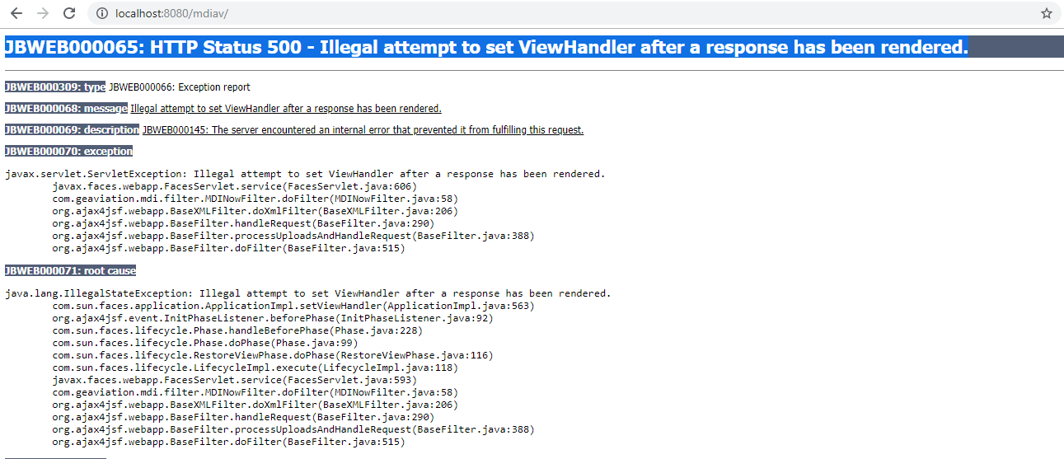

### Solution:

In web.xml add the following entry

<context-param>

<param-name>org.jboss.jbossfaces.JSF_CONFIG_NAME</param-name>

<param-value>Mojarra-1.2</param-value>

</context-param>

When we hit application <http://localhost:8080/mdiav/>

Application is up and worked fine except one menu in Search and two menus in Admin.

|  |  |  |  |  |  |  |
| --- | --- | --- | --- | --- | --- | --- |
| App | Env | Status | Identified by | Ticket | Assigned to | Remarks |
| mdiav | Local | Closed | Sarah, Radha | N/A | Vishnu | Tested by Sarah and Radha |

### Issue: Search Menu (Event Details)

org.apache.jasper.JasperException: javax.faces.FacesException: javax.faces.FacesException: javax.faces.FacesException: Cant instantiate class: org.richfaces.component.html.HtmlListShuttle

### Solution:

In searchEvent.jsp page

Deleted the following functionality from line no 85

<rich:listShuttle id="eventsShuttle" var="items" immediate="true"

sourceListWidth="200px" targetListWidth="200px"

sourceCaptionLabel="Available Fields"

targetCaptionLabel="Currently Selected Fields"

sourceValue="#{eventFlagBean.sourceList}"

targetValue="#{eventFlagBean.targetList}"

binding="#{eventFlagBean.listControl}"

fastOrderControlsVisible="false" orderControlsVisible="false">

<rich:column>

<h:outputText value="#{items}" > </h:outputText>

</rich:column>

</rich:listShuttle>

|  |  |  |  |  |  |  |
| --- | --- | --- | --- | --- | --- | --- |
| App | Env | Status | Identified by | Ticket | Assigned to | Remarks |
| mdiav | Local | Work in progress | Radha, Sarah | N/A | Vishnu | Planning to upgrade JAR version and try |

### Issue: Admin Menu (Manage Privelages)

JBWEB000068: message javax.faces.FacesException: javax.faces.FacesException: Cant instantiate class: org.richfaces.component.html.HtmlTabPanel.

18-09<Radha>

Update: Tried with different versions of richfaces jars still pages are not coming up.

The Jars are: richfaces-api-3.2.0.CR1, richfaces-api-3.2.1.CR1, richfaces-api-3.2.2.CR1, richfaces-api-3.3.1.CR1, richfaces-api-3.3.2.CR1, richfaces-ui-common-api-4.3.1.CR1.